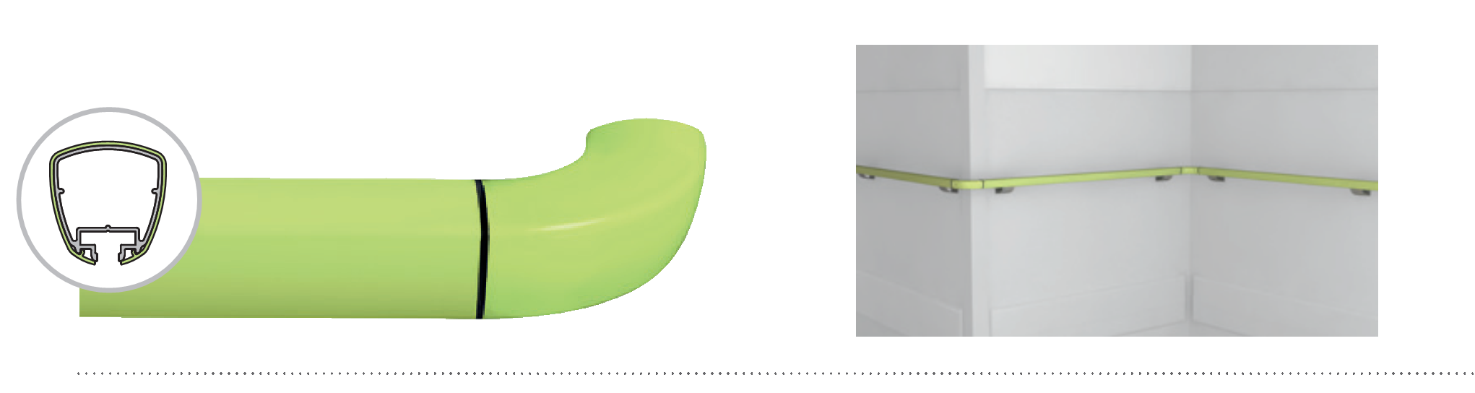
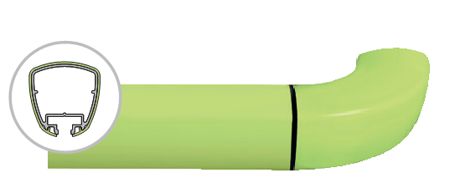
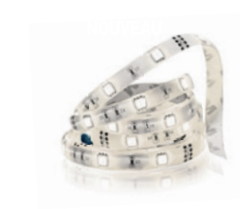

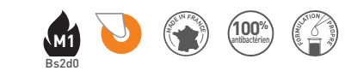
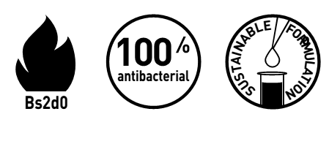
SPECIFICATION

LINEA’TOUCH LED – PVC SHEATHED
BACTERICIDAL JOINT

TRILOBED HANDRAIL - 40 MM WIDTH

- Package : Capentry/Joinery

- Description: trilobed handrail with antibacterial PVC sheath with lighting LED system (Linea’Touch LED PVC sheathed as manufactured by SPM) with a cross section from 28 to 40 mm to give it an ergonomic and anti-rotation design. It is 42 mm high and projects 80 mm from the wall. The axial position of its brackets provides an excellent guiding. It consists of a 2 mm thick continuous aluminium profile, covered by a 2 mm thick smooth and antibacterial PVC sheath, a wire connector, a LED band of 5 meters which can be cut every 50 mm, achieving Bs2d0 fire-rating with solid colour, and a closer underneath. A colour filter (Colour selected by architects from manufacturer’s standard range) can be inserted between the LED band and the closer. A protective film is specified to minimise cleaning before acceptance. Various smooth and antibacterial PVC accessories with solid colour (flat or bevelled endcaps, classic or extended and curved classic wall returns), supplied with bactericidal joints, are available to finish the handrail assembly and connect to the profile with joiner pieces. Wall fixing is by quick removable silver anodised effect aluminium brackets with 2-point self-locking 55 mm wide bugled bracket. The section comprises a groove into which brackets, accessories and closer slide and lock. All technical solutions are available to ensure continuity around corners (90° with integrated wired cable or made-to-measure with integrated wired cable), in staircases (3-way “universal joint” rotation angle - Rapid’Angle as manufactured by SPM), across service ducts (Quick-removable assembly wedge) and around curved sections (pre-curved in the factory) continuity ensured without LED system. These handrails achieve an impact resistance in excess of 70 Joules -i.e. an impact of more than 220 kg travelling at 2 kmh.

- Norms: CE compliant with European Directives, Class III (LED only).
- Environment electical components (LED bands and cables/connectors): compliant with RoHS Directive.
- Environment: no heavy metals and no substance potentially subjected to any REACH restriction are used in its manufacture, nor PBT/BPA. The calcium-zinc thermal stabilization process is used. The emission level of volatile substance in inside air has been tested according to ISO 16000-6 and is very low (A+) according to the French regulation (23 March 2011 nr 2011-321 Decree and 19 April 2011 Order). 100% of the product are recyclable.
- Colour: selected by architects from manufacturer’s standard range.
- Installation method: upper edge of section 0.90 m max. above floor level. Fixes to 2-point quick removable assembly self-locking 55 mm bugled bracket in aluminium screwed to the wall every 0.80 m to 1.20 m centres (0.80 m centres in heavy traffic corridors and on light partitions like plasterboard). Wall returns, endcaps and angles to be fixed with 2.5 mm Allen clamping screws. Operates with a 24 VDC constant voltage power supply box with sufficient power for a LED band of 9.6W/m (i.e : driver 24 VDC 60W supply by SPM).

Page 1/2


The power supply belongs to the Electrical installation package.
The electrical connection 24V belongs to the capendry/joinery package.
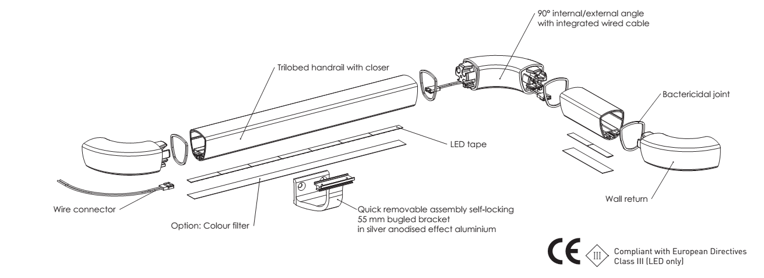

- Package : Electrical installation
- The trilobed handrail with lighting LED system (Linea’Touch LED PVC sheathed as manufactured by SPM), operates with a 24 VDC constant voltage power supply box with sufficient power for a LED band of 9.6W/m (i.e: driver 24 VDC 60W supply by SPM) which gets the following characteristics:

Output voltage Uout |  | 24 VDC
Max Power |  | 60W
Maximum lenght |  | 8 m

- The power supply belongs to the Electrical installation package.
The electrical connection 24V belongs to the capendry/joinery package.

Page 2/2

