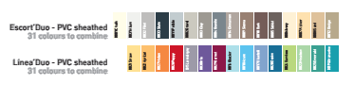
Specification

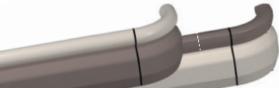

Escort’Duo pvc sheated

Linea’Duo pvc sheathed
Wall protection and handrails – 150 mm high

- Description: hand and wall protection rail (Escort’Duo or Linea’Duo as manufactured by SPM) from 2 mm thick and antibacterial PVC achieving Bs2d0 fire rating with solid colour. The 150 mm high system combines a tubular and smooth upper part: 40 mm round handrail (Escort’Duo) or 40 mm width trilobed handrail (Linea’Duo) and a lower wall protection rail matified. The PVC profiles snap-fixe onto continuous aluminium sections and finish is provided by antibacterial PVC accessories, smooth for the handrail and matified for the protection rail (wall returns, 90° internal/external angles). The unit is fitted into a PVC spacer. Bactericidal joints are provided for the junctions between profile sections and accessories.
- Environment: no heavy metals and no substance potentially subjected to any REACH restriction are used in its manufacture, nor PBT/BPA. The calcium-zinc thermal stabilisation process is used. The emission level of volatile substance in inside air has been tested according to ISO 16000-6 and is very low (A+) according to the French regulation (23 March 2011 nr 2011-321 Decree and 19 April 2011 Order). 100% of the product are recyclable.
- Colour: selected by architects from manufacturer’s standard range.
- Installation method: upper edge of section 0.90 m max. above floor level. Fixing on PVC spacers to be fitted at 0.80 m centres (0.60 m centres in heavy traffic corridors and on light partitions like plasterboard). Wall returns and angles fixing with self-drilling screws.

