Specification

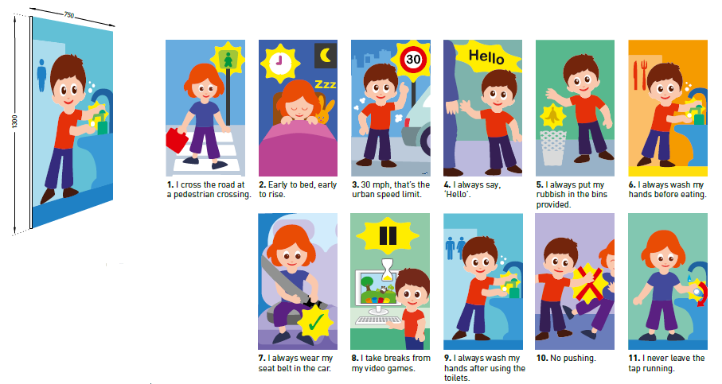

Decokid
educational panel

- Description: educational panel (Decokid as manufactured by SPM) from rigid, antibacterial and translucent PVC achieving Bs2d0 fire rating with a visual printed on the back. The surface is slightly textured (“Velvet“ grain as manufactured by SPM). Its width is 750 mm, height 1300 mm and thickness 1 mm.
- Environment: no heavy metals and no substance potentially subjected to any REACH restriction are used in its manufacture, nor PBT/BPA. The calcium-zinc thermal stabilisation process is used. The emission level of volatile substance in inside air has been tested according to ISO 16000-6 and is very low (A+) according to the French regulation (23 March 2011 nr 2011-321 Decree and 19 April 2011 Order). 100% of the product are recyclable.
- Colour: selected by architects from manufacturer’s standard range
- Installation method: glue, as per manufacturer’s instructions.

