 CREATION 70

CREATION 70 X’PRESS is a synthetic, decorative, flexible, abrasion group T, available in tiles and planks with beveled edges. Composed of a transparent wear layer 0.7mm thick, a design film and three compact underlayers reinforced with two fiber grids, CREATION 70 X'PRESS is 5mm compact product. Compressed and embossed at high temperatures.
The product includes “Pressure Sensitive Adhesive” (PSA) on the nylon backing, specifically for high traffic use, allowing no adhesive residue on subfloor after removal. The product is treated with a PUR + treatment for easy maintenance properties.

Product CREATION 70 X'PRESS is made with 83% of mineral and 6% inexhaustible materials. It does not contain formaldehyde, any heavy metals or substances CMR 1&2, vPvB (very persistent and very bioaccumulative) and PBT (persistent, bioaccumulative and toxic), and they are 100% compliant with REACH.
The product emission rate of volatile organic compounds is <100µg/m3 (TVOC<28 days - ISO 16000-6) and is rated A + (the best class) as part of the health labeling. It is 100% recyclable.

PUR+ treatment => sustainability & easy maintenance properties

Transparent wear layer
0.7 mm => traffic resistant

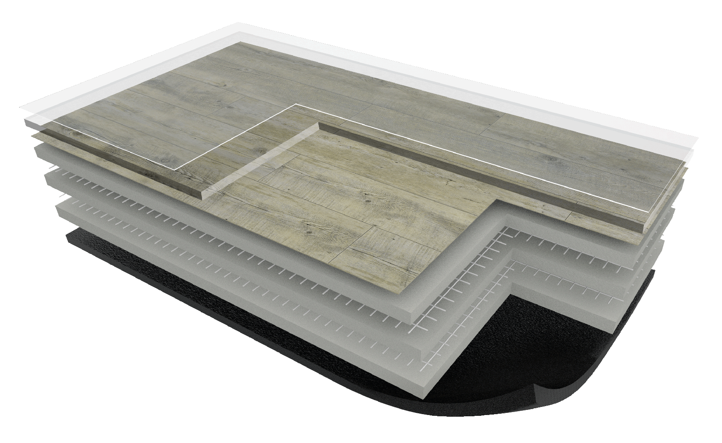
5 mm
Design film => Realism

Two fiber grids => excellent product stability

Pressure Sensitive Adhesive (PSA) => adherence repositionable

