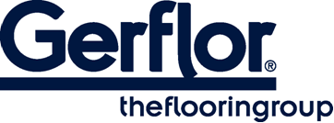 CREATION 40 SOLID CLIC

CREATION 40 SOLID CLIC is a decorative, abrasion group T floorcoverings available in tiles and planks, with bevelled edges. It consists in a 0,45 mm thick transparent wear layer, a design film of 2 m width printed in high definition to have more variety in the design and the technology “Duo Core 2.0”: combination of a rigid core back layer for easy renovation and a flexible core top layer to provide softness and comfort surface, the whole with a double reinforcement for enhanced durability. The overall thickness is 4,5 mm.
They benefit from a cross-linked polyurethane surface treatment (ProtecshieldTM), making maintenance easier and avoiding microscratches.

CREATION 40 SOLID CLIC is an interlocking floorcovering assembled with a vertical system on the short side and a horizontal system on long side for a quick and solid installation. It has a European class (residential / commercial / industrial use) 23/32/41 according to EN-ISO 10874 and has Bfl -s1 class for smoke emission according to EN 13501-1.

CREATION 40 SOLID CLIC is made with phthalate free plasticizers (except recycled content). It is 100% recyclable and made with a recycled content up to 55%. It is 100% compliant with REACH. The product emission rate of organic compounds is < 10µg/m3 (TVOC <28 days – ISO 16000-6).

