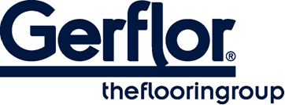 GERPUR

Glue specially designed for Dry Tex solution floorings

- Only for Dry Tex™ System (bonding of floors with non-woven backing DTX)
- Bonding on new and old humid concrete subfloor
- Mono component PU adhesive, reactive to humidity which enables the DTX material to be fully bonded in humid environment (no restriction of humidity levels with the exception of surface water)
- For laying instructions please refer to Dry Tex products instructions

