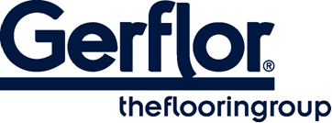
Tarasafe Ultra H₂O

TARASAFE ULTRA H₂O is a slip resistant vinyl floorcovering, with a PVC wear layer and deeply inlaid mineral particles and coloured chips for a decorative design together with a raised emboss for better slip resistance.

TARASAFE ULTRA H₂O is an ideal solution for traffic applications where enhanced slip resistance with barefoot and durability are required such as wet areas. The specific embossing together with the mineral particles gives a Class C barefoot slip resistance (DIN 51 097) and R11 shod slip resistance (DIN 51 130) which makes TARASAFE ULTRA H₂O ideal for barefoot or shod applications.

It is reinforced with a glass fibre grid in sheet form. Its homogeneous wear layer provides a group P of abrasion.

It does not contain any heavy metals or CMR 1&2 and it is 100% compliant with REACH. The product emission rate of volatile organic compounds is < 100 µg/m3 (TVOC after 28 days – ISO 16000 -6). This product is 100% recyclable and contents 18% of mineral material and 22% of inexhaustible material.

According to ISO 22196, it has anti bacterial activity against MRSA of 99% after 24h00.

