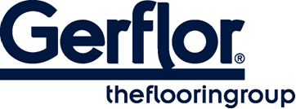 MURAL ULTRA

MURAL ULTRA is a flexible wall covering vinyl sheet which has a thickness of 1.5mm for an extended durability. It is designed to be a permanent wall covering.
It has a B-s2,d0 fire classification (EN 13501-1) which complies with most European fire regulations.

It is hot welded with CR40 welding rods for better hygiene and perfect water-tightness.

It is made of a pure PVC surface coloured throughout the whole thickness and a backing which comprises 25% of recycled products.

This multi-layered product is reinforced with a non-woven glass fibre grid for improved resistance to tearing and excellent dimensional stability.
Full resistant to impact, it acts as a buffer against damage from beds, trolleys and indoor motorized vehicles and other transportation systems.
MURAL ULTRA is fully impact resistant and is therefore ideal for use as a cladding in large public buildings such as hospitals care institutions dental and veterinary surgeries, clean rooms, stores and supermarkets, warehouse and storage areas.

It does not contain any CMR 1 & 2 component and is 100% compliant with REACH.
It is 100% recyclable.

MURAL ULTRA benefits from a Protecsol® surface treatment which provides good resistance to chemical products and makes maintenance easier.
According to ISO 21702, MURAL ULTRA has anti-viral activity against Human Coronaviruses : it reduces the number of virus by 99,7% after 2h00.
According to ISO 22196, MURAL ULTRA has anti-bacterial activity against E. coli, S. aureus and MRSA of 99,9% after 24h00.

